Virtual Visit Proposal
3rd Grade Field Experience
Color by Kelly Bourgeois
March-May 2021

Summary

The exhibition video tour includes comments from the artist Kelly Bourgeois and from young viewers talking about pieces in the exhibition. The hands-on lesson video is led by museum educator Sondra Hines and require 1 hour to complete.

The lesson blends art and science with expression of feelings and emotions. We ask students to work in pairs, and experiment with additive color process (mixing colored light) to design a simple stage set that exhibits an emotion or feeling of their choice. Students will explore aspects of additive color theory (mixing color with light) as it pertains and compares to subtractive color theory (mixing color with paint). Part of this includes becoming familiar with the primary colors for additive color theory (RBG) and explore the colors that can be made with these primaries.

Learning Objectives

Students will:
- Mix color using light; additive color process
- Practice prediction skills
- Practice observation skills
- Practice recording skills
- Create a three-dimensional stage set using simple materials
- Dramatize an emotion using only light and cut paper
- Consider qualities of lighting
  - Intensity
  - Color
  - Direction/shape/shadow
  - Focus/position (inside & outside of the stage)

Teaching Approach: Arts Integration

Teaching Methods:
- Discovery Learning
- Hands-On Learning

Assessment Type
Observation

Background Information

Color Theory-- In the visual arts, color theory is the guide to color mixing and the visual effects of a specific color combination. There are categories of colors based on the color wheel: primary color, secondary color, and tertiary color. A tradition of "color theory" began in the 18th century. The idea is colors affect our mood and perception.
Color can be classified in different ways…
- Warm and Cold
- Receding and Advancing
- Positive and negative
- Subtractive and additive

Additive Color--Additive color refers to color within light and when the primaries of red, green and blue, RGB, are mixed together, they create 'white light'.

Subtractive Color-- subtractive colors are created by completely or partially absorbing (or subtracting) some light wave and reflecting others. Subtractive colors begin as white, like a blank piece of white paper. As you add filters to the white light, such as paint, this white takes on the appearance of color.

LED-- a light-emitting diode

Materials Included

Additive Light Field Experience Kit
links to exhibition tour video
link to hands-on lesson video
link to hand-outs
Red, Green, and Blue LED lights
Coin Batteries
Binder clips
Masking tape
yarn/string

Materials Needed from classroom
white copy paper 5 sheets/pair of students
pencils (several/pair of students)
scissors

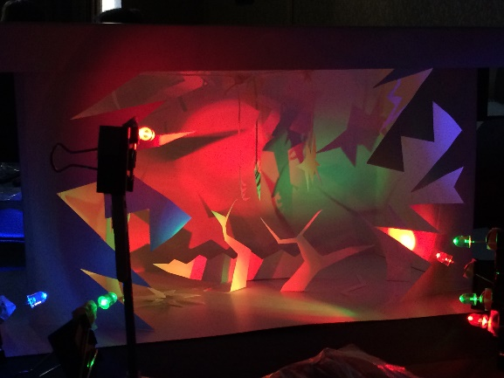
Photo of Additive color hands-on

